14.82: a)
b) Since 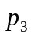 is atmospheric, the gauge pressure at point 2 is
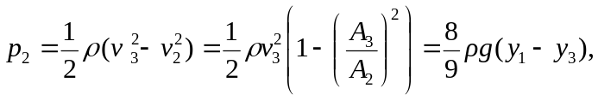
using the expression for 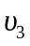 found above. Subsititution of numerical values gives 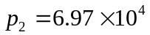 Pa.

